Distinguished
A Great Economic Leader
Markus Söder, Minister-President of Bavaria, awarded Thomas Kaeser, CEO of Kaeser Kompressoren, the Bavarian Order of Merit on Saturday evening in Coburg.
Coburg – “You can't buy it or inherit it, you have to earn it,” Söder stated during the award ceremony at Kaeser’s headquarters in Coburg. One must accomplish something exceptional to receive it. And with Thomas Kaeser, there are several noteworthy achievements to honour. Not only has Kaeser Kompressoren been economically successful for decades, but Thomas Kaeser has also distinguished himself through extensive participation in various economic forums. He is a “sustainable voice for the Upper Franconian economy,” whom he personally holds in high esteem. “You always have excellent ideas and suggestions for what can be done for the Upper Franconian economy,” Söder added. In an Upper Franconian economy that has undergone more change than almost any other, Thomas Kaeser has helped to manage transformation and structural change to become even more successful and expand Kaeser Kompressoren from Upper Franconia to the entire world.
It is also an accolade for the family business, Kaeser Kompressoren, since Thomas Kaeser, as a leader of a small-to-medium business, does not just confine the term to his immediate family, but applies it to the company as a whole. He is a highly successful economic leader, a thoughtful speaker, and possesses a unique authority that is appreciated and valued by others.
Thomas Kaeser was delighted with the award and promised to continue doing his best and applying his skills for the benefit of society and the company. He expressed his gratitude to the many people who have accompanied and shaped him throughout his life: his grandparents and parents, his six siblings, his friends and companions, the entire staff of 7500 employees, and most especially his wife Tina-Maria and his sons Jan and Philipp. “I want to share a part of the Order with those who have supported and influenced me throughout my life,” he said.

About Thomas Kaeser
Thomas Kaeser was born in Coburg in 1953, the third of seven children. His grandfather, Carl Senior, founded the present Kaeser Kompressoren in 1919, and his father, Carl, continued its success. Today, Thomas Kaeser, together with his wife Tina-Maria Vlantoussi-Kaeser, leads the family business, which now operates with around 7500 employees in over 140 countries worldwide. Thomas Kaeser is Chairman of the vbw-District Group of Upper Franconia, Chairman of the Western Region of the VBM and BayME, and CEO of the Association of the Metal and Electrical Industry in Thuringia. In addition, he is involved in the Board of the VDMA (Mechanical Engineering Industry Association), the Exhibitor and Trade Fair Advisory Board of the Hannover Messe, as well as the PNEUROP Council and the Exhibition and Trade Fair Committee of the German Economy (AUMA). In 2012, he was awarded the State Medal for Special Services to the Bavarian Economy.

About the Bavarian Order of Merit
The Bavarian Order of Merit has been awarded annually since 1957 as a symbol of honourable and grateful recognition for outstanding services to the Free State of Bavaria and the Bavarian people by the Minister-President. It symbolises the extraordinary commitment and outstanding contributions of the citizens of the Free State to the community. The first recipient was Konrad Adenauer. The number of living order holders should not exceed 2000; there are currently around 1600 living recipients of this Order of Merit.

Image:

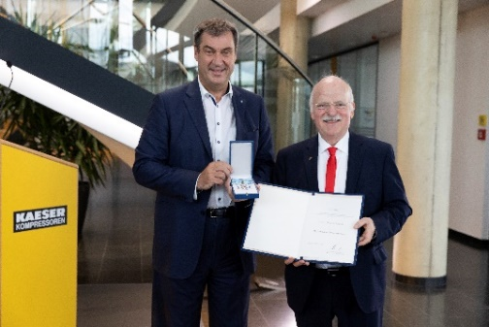

Markus Söder, Minister-President of Bavaria, distinguished Thomas Kaeser with the Bavarian Order of Merit.

