IFAT 2022
The low pressure experts
Kaeser blowers are the perfect example of the efficiency and future-oriented approach for which this Coburg-based compressed air specialist is renowned. At IFAT 2022 in Munich, the company will be showcasing solutions for every possible low-pressure application; not just high-efficiency rotary screw blowers – now fitted with synchronous reluctance motors – but also, for the first time, turbo blowers. Last but by no means least, the Sigma Air Manager 4.0 master controller, which binds multiple blower units together into a single, unified team that is simple and intuitive to operate, completes the picture.
For wastewater treatment systems in either communal or industrial treatment plants, bioreactors or flotation plants, operators seeking a reliable supply of compressed air with differential pressures up to 1100 millibar and a flow rate from 5 to 160 m³/min need look no further than Kaeser’s rotary screw blowers from the CBS to HBS series, featuring a power output of 7.5 to 250 kW. Up to 35% more efficient than conventional rotary lobe blowers, they also offer significant advantages in terms of energy efficiency and blower air availability over many turbo blowers in this power range. Kaeser rotary screw blowers particularly excel when operating at 100% duty cycles, where they are especially well suited to generating process air for the purposes of aeration in water treatment, flotation and fluidisation processes and in bioreactors.
The latest highlights from this model series are the FBS, with a flow rate from 18 to 72 m³/min, pressure differentials from 0.3 to 1.1 bar and motor power outputs from 45 to 110 kW, and the CBS, featuring a power range from 75 to 160 kW, flow rate from 22 to 104 m³/min and differential pressures up to 1100 mbar.
High-efficiency motors
Kaeser’s latest generation of variable-speed rotary screw blowers are equipped as standard with synchronous reluctance motors – highly efficient drive motors that are able significantly to boost the energy efficiency levels of units equipped with a frequency converter. The special rotor design used in this new generation of motors makes them extremely robust and durable. Furthermore, all Kaeser blowers are delivered as complete, turnkey machines including a Sigma Control 2 smart controller, which makes them particularly well suited to Water 4.0 applications.
Turbo blowers now available from Kaeser
The latest member of the Kaeser family is the PillAerator turbo blower, suitable for flow rates of 50 to 275 m³/min and differential pressures up to 1.3 bar. These extremely energy-efficient machines stand out for their intelligent design, whereby smart magnetic bearings operate completely wear-free, proactively controlling the position of the rotors. Furthermore, they are completely safeguarded against any potential power failure. As the bearings operate completely independently of speed, the machine is always ready for restarts, whilst the use of a cooling concept for core components that does not rely on ambient air ensures a particularly long-lasting and trouble-free operation.
Efficient control – the icing on the cake
For a modern, professional blower station, the Sigma Air Manager 4.0 master controller is an absolute must. Not only does it ensure optimal operation of each individual blower unit, but also that all units are operating together as a system in the most energy-efficient manner possible. Upon specifying the required setpoints for intake flow rate, standard flow rate or working pressure via the process control system, the Sigma Air Manager 4.0 then orchestrates the most efficient possible air supply and optimal load operation for each individual blower within the system. The operating data provided by SAM can further serve as a basis for an energy management system as per DIN EN ISO 50001 and DWA A 216.
Stand: Hall A1, 143/242

3.889 Keystrokes – Approved for publication, copy appreciated

Images:
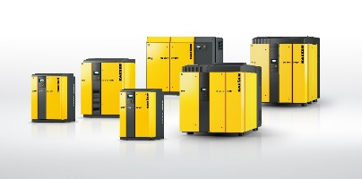
Rotary screw power from Kaeser: Powerful, quiet and energy-efficient, this range of models is capable of delivering low-pressure blower air for a wide variety of applications.
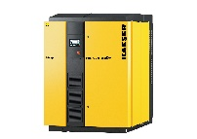
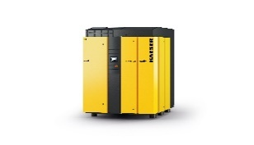
Kaeser completes the performance range with the introduction of the FBS and GBS series models.

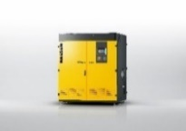

Equipped with contact-free and lubricant-free magnetic bearings, turbo blowers guarantee an efficient and completely wear-free operation.

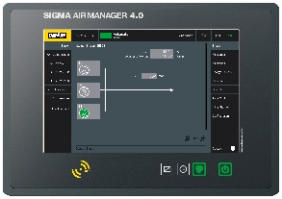

The Sigma Air Manager 4.0 monitors and controls all components in a blower station with maximum efficiency, whilst simultaneously providing the foundation for Water 4.0 technology.

